This 2 page document has the DM Sans font embedded.

This is the normal DM Sans character set:
3a in DM Sans
These are the required characters:
3a

How to do it with LibreOffice
Set the font to DM Sans
Type in the characters ie u3a
Select the 3 with the cursor
Click Format | Character then Features
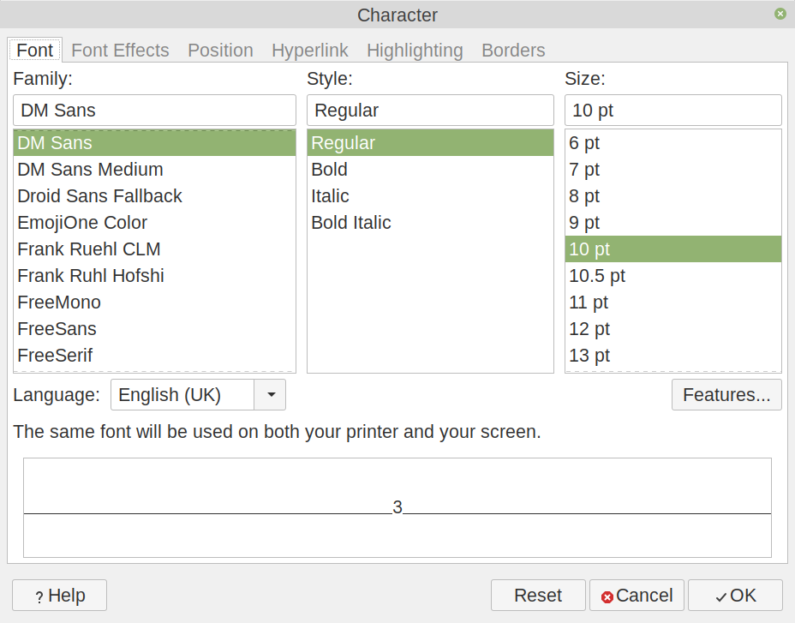
Then click on Stylistic Set 04 and OK then the 3 will change to 3

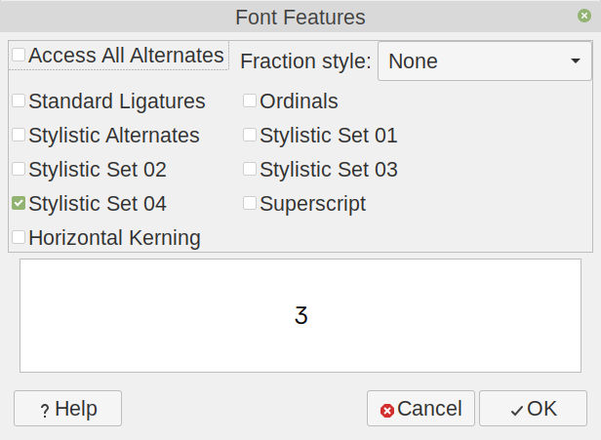

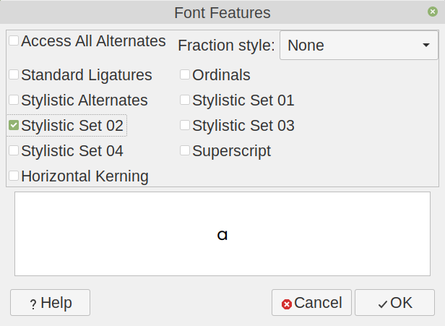
To change the a first select it then click Format | Character then Features and Stylistic Set 02 then OK to get a.

I have no idea how it works in other tools.
I raised a bug in LibreOffice because it did not work from Insert | Special Character. It was explained how to insert them. It now looks as though they will consider adding the Stylistic Sets into Insert | Special Character.

How to see it with FontMatrix
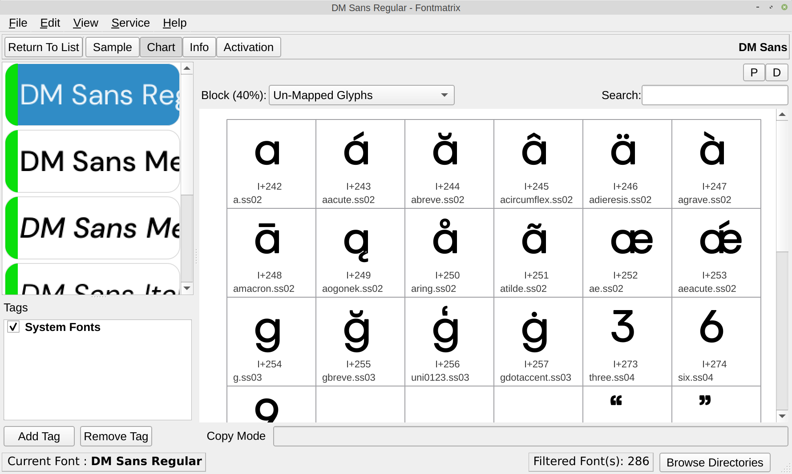
Here they appear as unmapped glyphs. They do not appear at all under mapped glyphs.

